**CommuniKate**

**The Open, Transferable, Symbol based, Page Set**

**Manual written by Dr Joe Reddington & Kate McCallum**

**Version 1.0, released 18/11/2014**

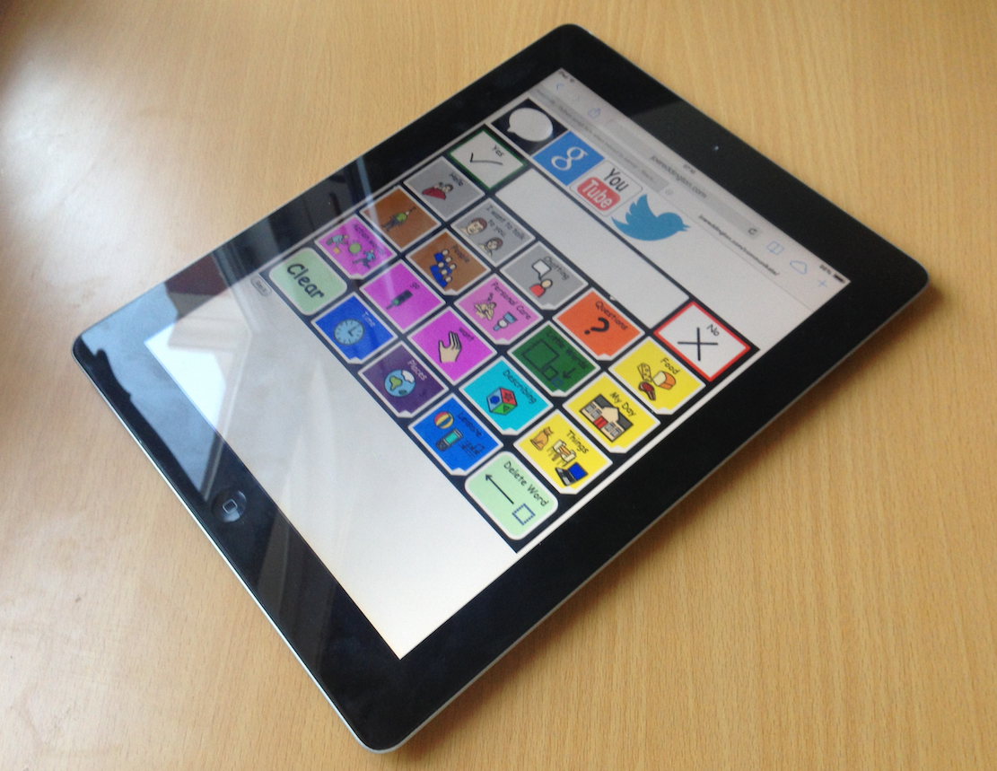

**Dedication**

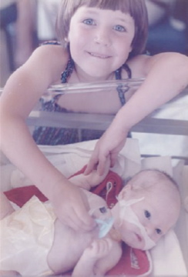

*To my little bro, I have no idea who or what I would be without you. You will never truly understand what you mean to me, that’s ok. You have taught me so much. CommuniKate would never have happened without you. Thank you!*

Kate

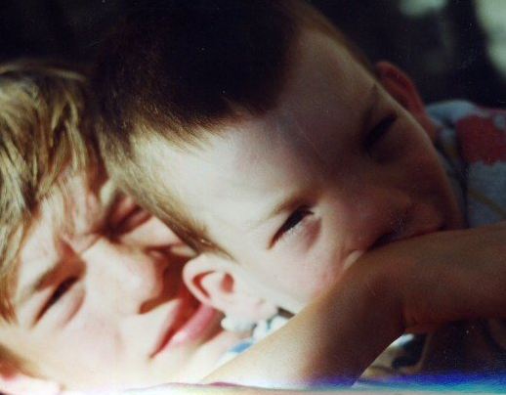

*For Richard, because life would be simpler if I did as I was told.*

Joe

**Acknowledgements**

I was enthused by a discussion group led by Dr Joe Reddington at Communication Matters conference in 2013. During this session he encouraged people to work together and discussed some of the issues facing the AAC field. This talk included an introduction to the possibility of open source approaches to AAC, he really challenged my thinking, as this was something I had previously thought might be a dream to far.

Much of the work to produce CommuniKate 20 has taken place late at night, on long train commutes, and via thousands of emails, Joe, I thank you for your time, endless hours of coding, patience and allowing me to constantly change and challenge what is possible. Your dedication and support to make this dream a reality and make CommuniKate 20 freely accessible has been and continues to be amazing. Thank you for saying “Let’s give this a try!”.

CommuniKate 20 would never have been published without the tireless support of all the people who from the beginning have used it, supported people who use it, helped to sculpt it, and enabled it to evolve into what it is today: thank you.

Janet Scott and the team at SCTCI, Janet when I began working with you I had no idea how steep my learning curve would be. You gave me such an amazing start in the AAC field, the best foundation on which to build my career, thank you for your continued support.

Alison Carpenter, Diana Mountain, Stef Armitage, and Catherine Maunder, you keep me out of trouble on a regular basis, you understand my passion for what we do, and the reason I fight so hard for the people we work with. Zak Sly, Neil Oughton, Rohan and Kathryn Slaughter, Trevor Mobbs, Fil MaIntyre, Sally Featon, and the whole team at Beaumont College. Thank you for everything.

Thank you Dave Morgan for giving me my first start in the manufacturers side of AAC.

Joan Bruno for having me as an intern at Camp Chatterbox, I learnt so much and had so much fun, but I have never drunk as much coffee in my life!

Nancy Inman, Tracy Kovach, Gail Van Tattenhove, and Communication Matters for your inspirational and informative study days.

Founders of 1 Voice: Katie Clarke and Tamsin Crothers, thank you for being simply amazing and all the role models, families and trustees who continue to network and support AAC users and their families all over the UK.

Kate

I owe a debt of gratitude to Kate first and foremost for helping me understand where I wanted to be in the world. For this work, I sucked in good ideas wherever I found them and I found many: Annalu Waller, Will Wade, Russell Smith, and the staff of a dozen companies were the sounding boards I needed. Mentors are one of the things you think you don’t need and then wonder how you ever lived without; thanks to Dave Whiteland for being mine. Honest friends are the things you wonder how you live *with* but know you need, thank you to Clare Walsh and Emily Dongray for being mine.

Thank you to Nava Tintarev for being my compass that points north. Accimedies called for a solid place to stand and a lever; Peter Moran is the solid ground I stand on. The others that I am proud to stand behind: Hannah Newton for regularly teaching me things I enjoy forgetting, Laura Smith and the group that silence me with stories, Amanda McGrath and the team that taught me that I could lead. I should thank Professors Johnstone and Scott for waiting patiently for me to evolve and my godchildren for needing the awesome now. Lastly I want to thank Fran Baker and Sarah Moffat for being to of the best proofreaders I could have.

Joe

**Contents**

Introduction 11

Who is CommuniKate 20 intended for? 11

History of CommuniKate 20 12

How can I try CommuniKate 20? 13

What makes CommuniKate 20 different for users? 14

Transferability 15

***How CommuniKate 20 helps*** 17

Sharing 18

***How CommuniKate 20 helps*** 18

Open Source 19

***How CommuniKate 20 helps*** 19

Design and Structure 20

***Overview*** 20

***Button Types*** 21

***Colour Coding*** 22

***Core Words*** 24

Page List 28

Page Detail 30

Everyday Use 35

Personalising CommuniKate 20 35

Blank templates for creating a new page 45

Adding Symbols 45

Step Through Guide 47

Creating a Low Tech Book 54

Searching for Vocabulary in CommuniKate 54

Further Information 56

CommuniKate 20 Online! 58

What 58

Why 59

***For people with devices*** 59

***For people without*** 59

How 60

Guarantee 61

The name ‘AzuleJoe’… 55

Making your own local version 61

Rights and Licences 61

Icons 62

Page set 63

Online Voice 64

Screenshots 64

This Manual 65

Future Plans 66

CommuniKate 20+ 66

CommuniKate 12 66

AzuleJoe 66

Localisation 66

Appendices 68

Testimonials 68

***Kate McCallum*** 71

***Joe Reddington*** 73

Bibliography 74

**Table of Figures**

Figure 1: The 'food menu' page from CommuniKate 20 11

Figure 2: Kate's Brother, with his AAC device 12

Figure 3: CommuniKate 20 running in a web browser 13

Figure 4: Joe's little brother with his device. 14

Figure 5 Joe's little brother, wearing climbing equipment that Kate sacrificed from her climbing kit. 17

Figure 6: The 'Top Page' for CommuniKate 20 20

Figure 7: range of colours used in CommuniKate 20 22

Figure 8: CommuniKate 20's Keyboard 23

Figure 9: Core words that are non-picture producing 24

Figure 10: Kate’s brother encouraging her to share his love of Halloween. (Scary).. 35

Figure 11: About me page 37

Figure 12: My Stories page 38

Figure 13: Leisure page 39

Figure 14: Places page 40

Figure 15: People page 41

Figure 16: WML page 42

Figure 17: Private Parts page 43

Figure 18: My Day page 44

Figure 19: Template page 45

Figure 20: A screenshot of the online version of CommuniKate 20 showing the buttons for 'speak', 'search Google', 'search YouTube', and 'tweet'. 58

Figure 21: Licencing Screenshot from http://straight-street.org/ 62

Figure 22: Kate's brother at Disneyland Paris with CommuniKate translated into French. 67

Figure 23: Richard getting Joe's attention. Possibly vice-versa 73

# Introduction

CommuniKate 20 is a socially focused page set designed exclusively for people who use augmentative and alternative communication (AAC). It was designed so that it could be easily used in conjunction with a low-tech communication book and as a progression from a book to a dynamic display device.

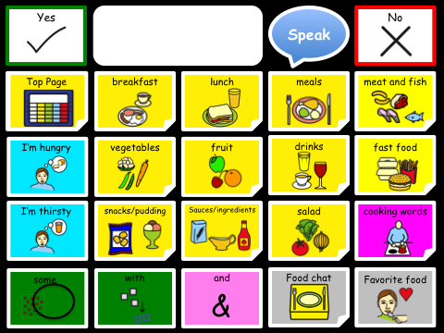

Figure 1: The 'food menu' page from CommuniKate 20

### Who is CommuniKate 20 intended for?

CommuniKate 20 is designed for people who rely heavily on the environment or context in order to communicate effectively but understand concepts and language used in conversation and during everyday activities. CommuniKate 20 supports emerging literacy skills and enhances comprehension by using photographs and symbols to represent language. It has been successfully used by people for whom access to a large number of cells is difficult, those with visual needs who require large buttons and text, and those using auditory scanning.

## History of CommuniKate 20

In 2001 Kate’s brother got his first communication aid. It did not have a page set that was appropriate for him so she wrote one. This was the beginning of CommuniKate. The original layout had just 12 buttons per page. However he progressed so quickly that soon 12 buttons did not give him the access to the volume of vocabulary he needed. CommuniKate 20 was written shortly afterwards and over the last decade has been modified and refined to work with the widest possible range of users.

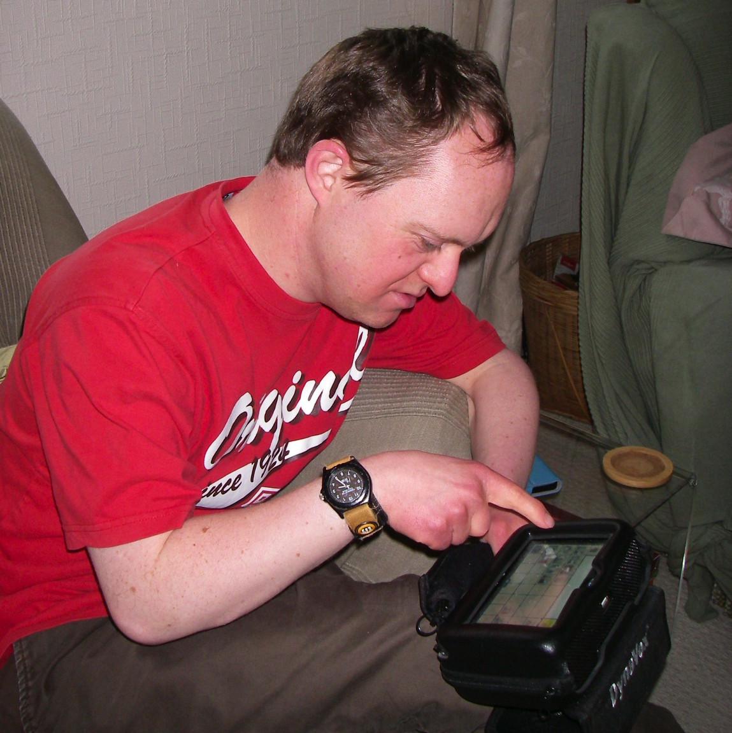

Figure 2: Kate's Brother, with his AAC device

## How can I try CommuniKate 20?

There are two easy ways to try CommuniKate 20. [This link](http://www.joereddington.com/communikate)[1] takes you to CommuniKate 20’s online support. The webpage contains a wide range of materials (including this manual). You can download the CommuniKate 20 page set in importable formats for both DynaVox Series 5[2] and Grid 2[3] and you can also try the page set directly by using [the online version](http://joereddington.com/communikate/)[4] (See Figure 6); for more information on how to use it or how to set up your own version locally see Section: ‘CommuniKate 20 Online!’.

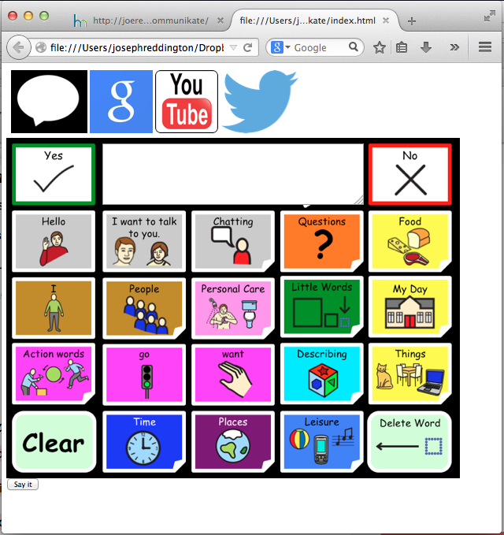

Figure 3: CommuniKate 20 running in a web browser

## What makes CommuniKate 20 different for users?

CommuniKate 20 isn’t only a standard page set, it’s an entirely free-to-use transferable page set. This means that there are no legal barriers preventing people from putting CommuniKate 20 on any device at all. As a result, if you are a CommuniKate 20 user switching to, say, DynaVox, you can download the DynaVox version of CommuniKate 20 and be able to use a familiar page set. CommuniKate 20 has an open licence under Creative Commons, meaning that it can be altered, shared, reused, and grow - all for free. This section goes into more details about why we believe having open page sets are vital for the AAC community, and how we’ve designed CommuniKate 20 to best match that need.



Figure 4: Joe's little brother with his device.

## Transferability

As a user’s ‘Voice’, the custom utterances and user history on an AAC device form not only a key part of the user's way of interacting with the world, but often, their memories and sense of self.

Manufacturers recognise that this data is precious and many manufacturers of electronic AAC systems offer the functionality to back up the devices to external storage. However, in the event of irrecoverable hardware failure, such backups are only generally useful if the user's replacement device is of the same model as the existing device (in some cases, manufacturers can transfer backups between different models of the same manufacturer). If it is the case that an AAC device's functional lifespan is longer than the device’s sales lifespan, then it is also the case that massive information loss must occur when a range's devices reach the end of their lifespan and users are shifted onto other devices. (Reddington 2014), provides some evidence of the extent of this problem).

*For those wanting an academic perspective on this sort of thing:*

*We consider these to be a counterpart of the work in (Deruyter et al., 2007); however, where (Deruyter et al., 2007) focused on increased interoperability between AAC and mainstream technologies, we argue in favour of increased interoperability between the devices themselves. The work is perhaps philosophically closer to the work of (Lesher et al., 2000b; Lesher et al., 2000a) which seeks to produce universal standards of logging of AAC utterances for research purposes. We argue that a standardised format would also allow technical researchers to develop their prototypes to interface directly with a user's existing systems. This would produce a much more seamless way of testing innovations, without the need to introduce users to dedicated equipment or a specialised app for testing a particular innovation in AAC technology.*

Moreover, because AAC device backups are not held in a common format, it is difficult for AAC users to transfer sets of pages between devices at all. If a user wishes to switch from, say Proloque2go to DynaVox, then the only way to transfer potentially key parts of their identity and memory between the devices is for the user, or care staff, to laboriously recreate systems by hand. This results in users having difficulties `trying out' new systems, and the occasional sight of a user with two AAC devices: one that is failing but has the full range of utterances, and a more modern device that may be clearer and more effective, but which does not yet have all the necessary utterances.

*For those interested in a personal perspective on this sort of thing:* Kate is going to use her brother’s AAC journey as an example; he has had four communication aids so far. Now imagine each time you change aid having to learn a new page set. I could give my bro a similar page set but in my view that’s not fair, it’s like me saying “OK, so for the past 4 years you have spoken French fluently. Well today, I’m taking away that ability and you are going to have to learn German“. As if life isn’t tough enough when you have a communication impairment.

Sadly, unless you have someone with the skill set to rewrite your page set, this is the reality. Even when an SLT has been involved, they have either had no programming experience, no time or no desire to implement the programming. So, to avoid him having to relearn a page set, every time he’s had a new device, I programmed CommuniKate 20 into it for him.

Since 2001 that is nine rewrites - no trivial task as depending on the software this can take up to 80 hours each time. I (or someone) could do training with the care staff, but with 6 staff changes in 10 months this is not realistic or a good use of time. Why so much programming? Well, firstly the data backups can’t be transferred or in a few cases, the data might transfer between two very similar devices, but certainly NOT across manufactures. Secondly, just like choosing a car, he needs to test drive the devices on offer before parting with thousands of pounds. Kate

It’s our[5] position that this shows a clear and present need for not only a standardised format for transferring sets of pages between devices but also that this standardised format be open and accessible to researchers.

### ***How CommuniKate 20 helps***

CommuniKate 20 isn’t a complete solution to the transferability problem, but it goes a long way. CommuniKate 20 isn’t a format for transferring page sets; however, because it is free to use on any platform, it can make it much easier to switch between devices. If you are currently using CommuniKate 20, and your new AAC device is a DynaVox, then you can download the DynaVox version of CommuniKate 20 from the website[6] and be using a familiar page-set extremely quickly. If a device is broken for a few days, then the [online version](http://www.joereddington.com/communikate) can help with basic communication in the meantime. Moreover, if a new AAC device enters the market, CommuniKate 20 only has to be transferred once. Once one person has made the transfer, we can store the device backups online for anyone to make use of.

## SSD:Users:josephreddington:Dropbox:latexPapers:submitted:splat2013:aac2.jpg

Figure 5 Joe's little brother, wearing climbing equipment that Kate sacrificed from her climbing kit.

## Sharing

Human language evolves culturally rather than individually. The nature of society is such that whole communities take on new topics of conversation at once. At the time of writing ‘The Great British Bake’ off is a major topic of conversation, as is Scottish independence, and the prospect of a new royal baby.

There is an acknowledged problem in the AAC community that because of the effort required for new utterances to be added to communication devices, AAC-users are left unable to discuss current affairs. This applies even when such current affairs are extremely long running cultural artefacts (the TV-show ‘Breaking Bad’ for example).

Ideally, there would be repositories where users could share language packs and have them easily viewable by other members of the AAC community. These language packs wouldn’t just include current affairs but also any form of special event (‘Christmas’, ‘Weddings’), activity with specialist language (‘Cricket’, ‘Thai cooking’), or any media (‘Yes Minister’, ‘Mr Bean’, ‘GTA5’). Within education this might include relevant packs for particular lesson plans, or the week’s dinner menu.

## Some AAC manufactures have embraced this approach. Tobii and Sensory Software, for example have websites devoted to sharing pagesets[7][8] – but unfortunately only for their respective software. In general, not only is it difficult to share the actual files, it is difficult to share images of the files. Section ‘

Screenshots’ talks in detail about the problems with screenshots of pagesets.

### ***How CommuniKate 20 helps***

Because CommuniKate 20[9] has been carefully designed with sharing in mind, it lends itself very well to this issue. The open licencing structure we have used (See the Rights and Licences section) allow users to both freely modify existing pagesets (because the arrangement of the pages is openly licenced) but also display those changes easily (because the layout and colour schemes are also openly licenced). By encouraging users, therapists and assistive technologists to release their work freely, the whole area can benefit from the countless hours of investment that are put into pageset design.

## Open Source

The AAC field has many manufacturers but lacks an open source solution. This is particularly odd because the Open Source/collaborative design movement is well established and exists in almost every category of software. Indeed, in many cases (for example, Firefox, and Chrome[10], Wikipedia, Reddit, and WordPress) the open-source solutions dominate their commercial competitors.

However, AAC lacks an established open-source solution, in part because it has not had a fully designed and tested pageset to work towards. An open source AAC device must have an open licenced page set to work on or risk legal consequences.

### ***How CommuniKate 20 helps***

We believe that CommuniKate 20 can be the first such pageset. Because it is openly licenced and available in a machine-readable format, it is easy for programmers to use as a starting point – to test their systems and develop further. Indeed, later sections of this manual will discuss AzuleJoe, which is a minimalist Open source viewer for the CommuniKate pageset, although it can be retargeted and improved by any programmer.

We appreciate that this aspect may well be less relevant to SLTs on the front line and families who are working hard to get communication for their loved one – we certainly understand that. But we include this here for completeness and because we believe that working towards having an open source AAC solution will improve countless people’s lives in the future, particularly in the developing world.

## Design and Structure

CommuniKate 20 is a hierarchical page set, focused on a *Top Page (*See Figure 6)that links, by means of symbols and photographs, to a range of subpages categorised by semantics, carrier phrases, or sentences. It contains functional core words and motivational vocabulary, which is essential to support AAC users.

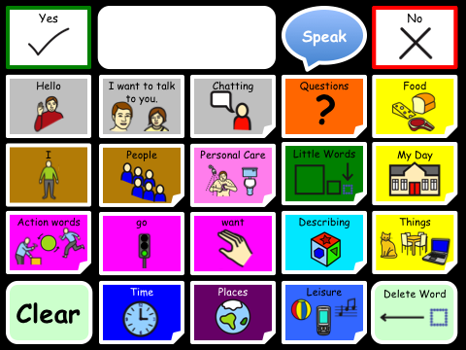

Figure 6: The 'Top Page' page for CommuniKate 20

### ***Overview***

Consistency is key in the design of a page set allowing a user to navigate easily and begin to use Language Acquisition through Motor Planning (LAMP) techniques (Halloran 2007). In CommuniKate 20 every page links back to the Top Page and the Top Page button is always in the same place. This consistent design is also keyguard friendly.

## The vocabulary needs of users change constantly, so CommuniKate 20 includes template pages that can be filled in with language and links that are personal to the user. For more information see the section ‘Everyday Use

In ideal circumstances any user of AAC would be supported by an AAC assessment team. Unfortunately, due to funding issues, and assessment delays, we are aware of a large number of users, families, and other support setups that are having to make their own way forward in providing access to communication. We are particularly aware that for users outside the UK, there are often no professional services available at all.

This section outlines those parts of our experience that might be of interest to people who are isolated from professional support. This should, of course, be in no, way considered professional advice. It also includes some details about pragmatically using CommuniKate 20.

Personalising

### ***Button Types***

There are three different types of buttons in CommuniKate:

|  |  |  |
| --- | --- | --- |
| Symbol button |  | These buttons are rectangular and contain words, sentences or carrier phrases. |
| Function button |  | These pale green buttons have rounded corners and perform a function such as clearing the message window or backspace. |
| Link or navigation button |  | These navigate to another page and have a fold in one corner. |

CommuniKate 20 was deliberately designed so that each button type was distinct in shape, colour and behaviour. We note that, of course, on some platforms, some aspects of the shape cannot be replicated and slightly different ones will be used.

### 

### ***Colour Coding***

Colour coding has been used for years as a way of supporting learning of different word groups and aiding navigation. Equally it enables the communication partner to easily facilitate Aided Language Stimulation because they are only then looking in the coloured category for the target word.

CommuniKate 20 has a range of semantic categories which follow and expand on the range of colours of Goossens’, C., Crain, S., & Elder, P. (1992). (See Figure 7)

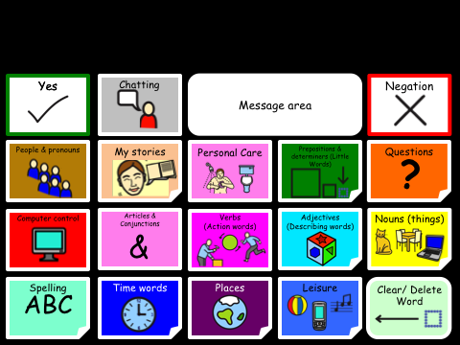

Figure 7: range of colours used in CommuniKate 20

**Optional features**

CommuniKate 20 contains a keyboard to encourage scribble writing and emerging literacy skills.

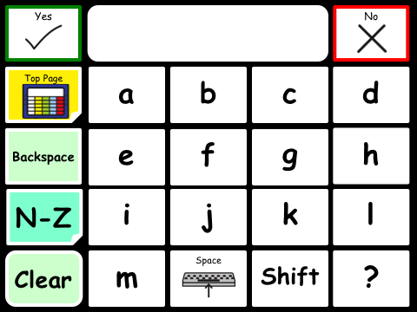 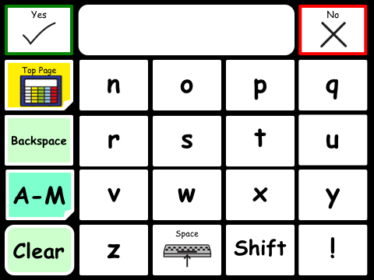

Figure 8: CommuniKate 20's Keyboard

### ***Core Words***

The 100 words we most frequently and commonly say account for around 50% of words spoken in the English language. (Kucera and Francis, 1967). *Core words* are important for carrying meaning but they are not always recognised as important possibly because it is not easy to produce a picture for these words.

Figure 9: Core words that are non-picture producing

Many core words cannot easily be represented by a picture. Figure 9 shows the symbol for ‘here’ as an arrow and a cross, which for the non-reader requires a certain level of word knowledge and representational understanding to interpret. Similarly, sentences cannot easily be represented by a picture. Hence, many individuals will require some teaching to effectively use these words.

CommuniKate 20 has been designed to give access to a high percentage of core words, enabling them to give clearer meaning to their utterances. Gail Van Tattenhove, SLP, produced a Core Vocabulary List for Students with Intellectual Disabilities (2011). CommuniKate 20 includes 214 of the 228 words in this list. The missing words are: her, hers, him, his, your, are, does, did, has, had, hurt, (but we do have ‘Ouch’), mad, silly and smart. We also have ‘Lady’ rather than ‘woman’; ‘personal assistant’ rather than ‘aid’ and ‘thing’ rather than ‘stuff’.

CommuniKate 20 contains all the core words identified by Banajee, DiCarlo & Sricklin (2003). Banajee et al studied the frequency of vocabulary used by toddlers and found that the 23 words shown in Table 1 accounted for 96.3% of the words spoken.

|  |  |  |  |  |
| --- | --- | --- | --- | --- |
| 9.5% | 8.5% | 7.6% | 5.8% | 5.2% |
| 5.0% | 4.9% | 4.9% | 4.9% | 4.6% |
| 4.4% | 3.8% | 3.2% | 3.1% | 2.8% |
| 2.7% | 2.7% | 2.6% | 2.4% | 2.3% |
| 2.3% | 2.1% | 1.0% |  |  |

Table 1: Word frequencies found by Banajee

**Conversation scaffolding support**

CommuniKate 20 has been designed to facilitate conversational flow wherever possible.

User: Top Page→Personal Care → “I don’t feel well”

*This takes the user to the ‘I don’t feel well’ page.*

Partner “Oh dear what’s wrong?”

User: **“I have a pain in my…”**

*This keypress both adds the utterance “I have a pain in my “ to the message window and also automatically opens the ‘body parts’ page, so that the user can complete the sentence conversationally.*

Example 1: User keypresses when reporting illness.

Example 1 and Example 2 show conversations between a CommuniKate 20 user and their conversational partner that demonstrate the CommuniKate 20 conversational scaffolding. This approach is used in several places in the CommuniKate 20 page set and is supported by the AzuleJoe framework used online (See Section ‘CommuniKate 20 Online!’).

User: Top Page → Food and drink page → “I’m thirsty”

*This last keypress both adds the utterance “I’m thirsty“ to the message window and also automatically opens the ‘drinks’ page, so that the user is in a naturally following part of the pageset.*

Waiter “What would you like to drink?’

User: “Smoothie” button navigates to the flavours page

*This keypress both adds the utterance “Smoothie” to the message window and also automatically opens the ‘favours’ page, so that the user is in a naturally following part of the pageset.*

Waiter: “Which smoothie would you like?”

User: Strawberry *navigates back to drinks page*

Water; “What size would you like?”

User: (From drinks page) → describe → medium

Example 2: A CommuniKate 20 user ordering a drink

## Page List

* About me
* About you
* Action words
* Alcoholic drinks
* Animals menu
* Art things
* Birds
* Breakfast
* Body Parts
* Chatting
* Christmas
* Clothes
* Colour
* Common things
* Computer
* Cooking words
* Days
* Describe
* Drinks
* DVD’s
* Education staff
* Family
* Farm animals
* Fast food
* Feelings
* Fizzy drinks
* Flavour
* Food
* Food chat
* Friends
* Fruit
* Furniture
* Gardening
* Health
* Insects
* Job
* Juice
* Kitchen equipment
* Leisure
* Little Words
* Lunch
* Materials
* Meals
* Meat
* Milkshake
* Money
* Months
* More Action Words
* MP3
* My Day
* My stories
* Nature Menu
* Numbers
* Office
* Opposites
* Outside
* Private parts
* People
* Personal care
* Pet care
* Pets
* Photo Album
* Photo Menu
* Places
* Position words
* Private parts
* Questions
* Salad
* Sauces
* School/work friends
* Shapes
* Shops
* Snack
* Special days
* Spelling
* Spelling 2
* Sports
* Support staff
* *Template Page
* Things
* Things that help
* Time
* Toiletries
* Tools
* Transport
* TV
* Vegetables
* Want
* Water animals
* Weather
* Wild animals
* WML

## Page Detail

The Top Page of CommuniKate 20 links to a range of semantic categories, many of which have further links to pages relating to the category. This section describes the designs decisions that informed the page layout.

|  |  |
| --- | --- |
|  | *Chatting:* - contains a selection of interjections and manners to enable the user to comment (e.g. please, ok, so, I’m fine). This category further links to: *About Me* – which links to *- Tell me about you.* It also links to - *My Stories* and to – *WLM.*  *NOTE:* Please see section on personalising CommuniKate. |
|  | *About me: -* Is a template page in which the user can add as much or a little detail as they wish to share. (e.g. My name is…, I live with…) |
|  | *WML:* - Stands for Whatever, Minga, Looser, a page of statements such as: “You’re doing my head in” and “rubbish”. Enabling the user to quickly comment or express an opinion. |
|  | *Tell me about you: -* mirrors the *About me* page allowing the user to find out personal information about someone else.  (e.g. What’s your name?, How old are you?) |
|  | *Questions: -* Contains question words, and commonly used question sentences. (e.g. what, when, who & What have you been doing?) |
|  | *Food: -* Contains some core words (e.g. some, more and) and phrases relating to food (e.g. I’m hungry, I’m thirsty). It links to a large range of semantic categories relating to food: |
|  | *People:* - Contains common pronouns (e.g. I, you, he, they) and links to a set of template pages, *friends, school/college/work mates, support staff, education staff* and *family*. It also links to *jobs* page. |
|  | *Personal Care: -* Provides a guide to the type of phrases the user may wish to convey. (e.g. I’d love a bath, I need to get changed). It links to *clothes, toiletries, body parts,* which further, links to *Privet parts*. It also carrier phrases such as “*I don’t feel well”*, which links to a *Health problems page*. And a carrier phrase that links to *Things that help*. e.g. switch, wheelchair… |
|  | *Little words:* - Opens to articles, prepositions and conjunctions (e.g. all, to, is, the) and a further linking to additional *prepositions page* (e.g in, on, under, there). |
|  | *My Day:* - Is a template page designed to be personalised for the individual user with links to pages specifically relating to their day. Additionally it also links to a *keyboard*. The link to a *computer access* page will differ depending on the platform CommuniKate is used on. |
|  | *Action Words:* - Opens to a page of high frequency Action words (verbs) and two additional pages for more high frequency verbs.  (e.g. do, stop, like, take, have, try, feel.) |
|  | *Describing:* - Opens to a page of high frequency adjectives (e.g. more, right, different, favourite) and links to pages - *Feelings, colours, shapes and opposites* |
|  | *Things:* - Opens to a range of semantic categories *(Tools, Furniture, Office)* some of which have sub menus such as Nature which opens to: *Animals:* which links to *Pets, Farm animals, Birds* and so on… |
|  | *Time*: - Opens to a range of high frequency time related words (e.g. today, later, morning, after, again, now) and links to *Days, Months* and *Special days.* |
|  | *Places:* - Opens to a range of generic places (e.g.town, hospital, pub) and provides links to *‘My day places’* , *‘Shops’* and to ‘*Outside Places’* |
|  | *Leisure:* - Opens to a page of optional links such as: *Photo album, phone page, MP3,* *DVD player,* *Environmental controls (ECU)* and *My Stories*. It also contains a volume control for the user to enable them to make their voice louder or quieter depending on their personal preference and their environment.  The remaining pages link to template pages, which are designed to be personalise for the user. |
|  | *My Stories:* - Opens to a template page designed to be personalised for the individual using CommuniKate with stories and memories they wish to share. |
|  | *I don’t feel well: -* Opens to common health related problems which arepredominately positioned in the same places as the ‘*body parts’* e.g. “headache” is in the same position as “head”, “stomach ache” is in the same position as stomach. |

## Everyday Use

In ideal circumstances any user of AAC would be supported by an AAC assessment team. Unfortunately, due to funding issues, and assessment delays, we are aware of a large number of users, families, and other support setups that are having to make their own way forward in providing access to communication. We are particularly aware that for users outside the UK, there are often no professional services available at all.

This section outlines those parts of our experience that might be of interest to people who are isolated from professional support. This should, of course, be in no, way considered professional advice. It also includes some details about pragmatically using CommuniKate 20.

### Personalising CommuniKate 20

Every person who uses AAC has different needs, wants and interests. Editing CommuniKate 20 to customise and personalise for each individual is essential.



Figure 10: Kate’s brother encouraging her to share his love of Halloween. (Scary)

There are two types of edits that should be performed, firstly there are standard phrases which need personalising before full time use. This includes such things as finishing phrases like *"I live in..."* on the about me page. Secondly there are longer-term edits that reflect the changing needs of the user, such as adding the names of new care staff. CommuniKate 20 contains a number of empty buttons and a series of blank/template pages, intended for exactly this customisation. Ideally this editing should be done with the user to promote ownership of the program and aid location and learning of the new vocabulary being stored.

We suggest the following pages are personalised for the CommuniKate 20 user:

#### About Me

Should be personalised to reflect the person using the device, it can be filled in with as much detail as the user wishes to share. It’s important to consider the users ability and understanding of the disclosure of personal information. For example, for some users, it maybe best to add utterances such as: “I live in Sunnyside” rather than disclosing a full address and postcode.

#### 

Figure 11: About me page

**My Stories**

We all have a collection of stories or memories of events that we like to talk about. We call upon these stories at different times. We feel AAC users should have the same ability hence the my stories page is intended to be filled with personal stories the AAC user may wish to share, e.g. “Once whilst I was sailing on my friends boat, we were out at sea. I looked around us and was amazed to see dolphins surrounding the boat. They followed us for ages, it was so special.” NOTE: It’s important to program carefully, e.g. Avoid putting in “It’s my birthday in three weeks time”, or “Last week, I went to ……” because ‘Last week’ will soon become ‘Last month, Last year’ and you will need to edit lots more. Instead use, “On my holiday” or “In May 2014, I saw….”

#### 

Figure 12: My Stories page

#### Leisure

The leisure page is designed to be personalised for the individual using CommuniKate 20 with leisure activities or personal interests such as a page dedicated to Thomas the tank Engine Characters, Star Wars or a page relating to Facebook or Twitter. Equally the *MP3,* *DVD player,* and *Environmental controls (ECU)* can be edited as the user desires but these pages will differ depending on the platform CommuniKate 20 is used on and it’s capabilities.

We all have a collection of photographs taken with our smart phones and many of us enjoy sharing these and talking about the picture with others. We feel AAC users should have the same ability hence the *Photo Album* can provide a motivating way for a user to initiate a conversation and to share their experiences. CommuniKate 20 provides the user with a template page, which is as easy to construct as a regular page.

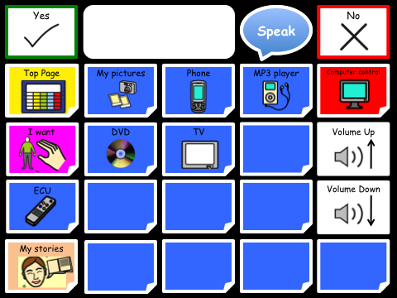

Figure 13: Leisure page

#### Places

*My day places,* is a template page designed to be personalised for the individual user which specifically relates to their day. For example, a day centre or after school club with a specific name would be programmed here. *‘Shops’* and *‘Outside places’* should also be personalised to reflect the places the user is likely to want to talk about; such as Tesco, Sainsbury’s or local pubs or restaurants.

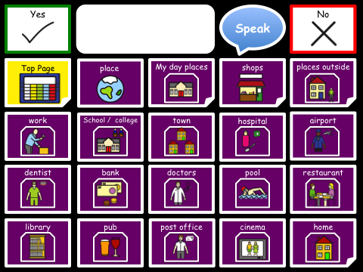

Figure 14: Places page

#### People

*People* Contains a set of template pages that are intended to be personalised for the individual user. These include, *friends, school/college/work mates, support staff, education staff* and *family.* For many people with disabilities staff are constantly changing and there is a tendency for old staff to be removed/ edited out of page sets. It’s important to remember even though the individual staff member may not work with the CommuniKate user anymore they may still wish to talk about them or reminisce about events that staff member was involved in, hence you may wish to use sub categories to organise this section logically for the CommuniKate user.

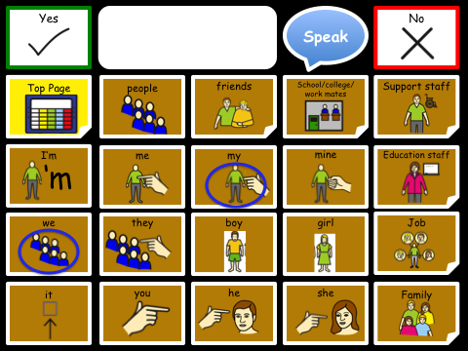

Figure 15: People page

#### WML

You will notice yourself when you are chatting with friends, texting or using social media you will commonly use similar words: “Wonderful, awesome, fantastic, ridiculous”. This page is designed to give the AAC used the same opportunity but needs personalising to reflect the users age and personality, e.g. A child may wish to say “Poo, poo, Bottom, and “No way” where as a teenager/ adult may wish to user more expressive and/or explicit language.

#### 

Figure 16: WML page

#### Private parts

*Private parts* contains some mildly explicit language which may need editing to meet the age and personal preference of the user.

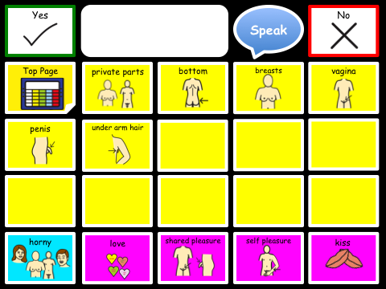

Figure 17: Private Parts page

#### My Day

*My day* is a template page designed to be personalised for the individual user with links to pages specifically relating to their day. For example if the user goes to a day centre and does a specific activity lets say ‘photography’ it will link to a page with vocabulary relating specifically to this subject.

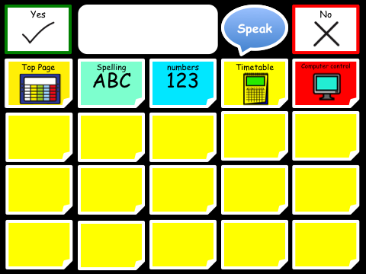

Figure 18: My Day page

### Blank templates for creating a new page

In the background of communicate there are premade template pages to aid quick page creation. It’s important to be consistent in the design and layout of pages to support the users use of the language pack. Equally the colour code should be followed where possible.

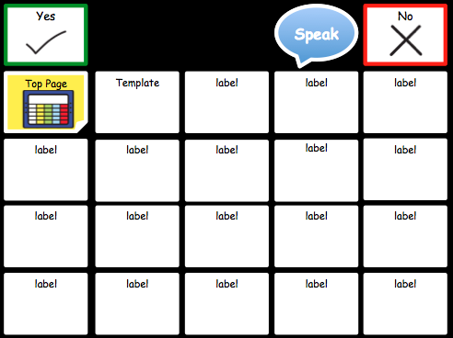

Figure 19: Template page

### Adding Symbols

It can be natural to think that you should not add symbols/words to an AAC system until the user can clearly demonstrate understanding of the utterances. This has been effectively debunked (See References 8 thought to 11). Without exposure and the ability to use new language, learning the meaning of new vocabulary can be significantly impaired. Equally learning the appropriate context in which to use a word is challenged with out exposure to it. Kate has the following parable on the topic.

Aided language stimulation or modelling language are techniques we recommend you explore further to teach language.

My three year old (typically developing) son is commonly heard producing utterances such as: “Actually, Mummy, you don’t need to worry I’m a professional.” (Usually as he follows his brother on increasingly risky adventures usually involving heights). He has no real understanding of the word “actually” or “professional” but with my support and guidance I can begin to model and teach the meaning of these words and how to use them in context. The same is true of an AAC user, with the correct support many will be able to produce novel utterances independently.

*Equally (as revolting as little boys are and girls to though I’ve not had much experience of them yet) he has been heard shouting “Poo”, (could be worse) over and over again, and yes, as most children do, in the most inappropriate place (usually the most embarrassing of circumstance for me). With my guidance he is learning the appropriate place to say such utterances. (Slowly, I may add, but that’s natural I’m told).* The same is true of an AAC user, with the correct support they to will learn the appropriate place and circumstance in which to use or not use certain utterances.

Kate

### 

### Step Through Guide

This step through guide is aimed at supporting you the communication partner and the user to gain competency and an understanding of CommuniKate.

A key advantage of CommuniKate’s dedication to being open and transferable means for example, even if the user is using CommuniKate on a dedicated device the communication partner can explore CommuniKate on any platform they choose, such as a tablet or iPhone

The communication partner can support a user to learn new words using simple techniques such as modelling where a communication partner demonstrates how to expand utterances to the user.

All users are unique and will be at differing language levels. You can, depending on the individual, begin at the start of this guide or jump in at the level that best suits the individual’s language capability. We offer this as a suggestion, ideally, a qualified SLT should design the CommiKate program for the individual user.

**Phase 1: Introducing Core, (none picture producing) language.**

|  |  |
| --- | --- |
| USER *wants an apple.* | |
| USER: |  |
| CP (modelling) |  |

*Here are some further examples for you to try:*

|  |  |
| --- | --- |
| *USER* *wants to go swimming.* | |
| USER: |  |
| CP (modelling) |  |

|  |  |
| --- | --- |
| *USER* *wants to tell Dad something.* | |
| USER: |  |
| CP (modelling) |  |

|  |  |
| --- | --- |
| *USER* *wants to put something in the bag* | |
| USER: |  |
| CP (modelling) |  |

**Phase 2**

Once the user is competent linking 2/3 part phrases using core and fringe vocabulary you can then begin to add words by modelling 3/4 part phrases.

Slowly, you can begin to add in negation, some question words and description. You could try these:

|  |  |
| --- | --- |
| *USER* *points at bacon and shakes head.* | |
| USER: |  |
| CP (modelling) |  |

|  |  |
| --- | --- |
| *USER* looks at clock and gestures towards them self | |
| USER: |  |
| CP (modelling) | “?’ |

|  |  |
| --- | --- |
| *USER* looks towards a pint glass and his friend | |
| USER: |  |
| CP (modelling) |  |

**Phase 3**

A user who is competent using 3 /4 word sentences can then begin to learn to add in further description and feelings. Try these:

|  |  |
| --- | --- |
| *USER* points to their tooth, which has a new filling. | |
| USER: |  |
| CP (modelling) | “”. |

|  |  |
| --- | --- |
| *USER* looks sadly at the washing machine which contains their t-shirt | |
| USER: |  |
| CP (modelling) | “.” |

|  |  |
| --- | --- |
| *USER* looks at friend who is sleeping on the sofa | |
| USER: |  |
| CP (modelling) | “ ” |

**Phase 4**

Once a user begins to use feeling and description in a 4 part phrase you can then begin to teach them reasoning, for example:

|  |  |
| --- | --- |
| *USER* looks at the empty pudding bowl. | |
| USER: |  |
| CP (modelling) | “.” |

|  |  |
| --- | --- |
| *USER* hugs friend that they care about. | |
| USER: |  |
| CP (modelling) | “ ” |

|  |  |
| --- | --- |
| *USER* looks at shopping bag they got in town on Saturday. | |
| USER: |  |
| CP (modelling) | “ ”. |

Add in more question words:

|  |  |
| --- | --- |
| *USER* looks at the calendar in their phone | |
| USER: |  |
| CP (modelling) | “,?” |

Add in past and future tense. We acknowledge that this is currently quite difficult however as you will discover in the section ‘Future Plans’ this is something we aim to address in the near future.

|  |  |
| --- | --- |
| *USER* puts the working remote control car on the ground and smiles. | |
| USER: |  |
| CP (modelling) | “” |

**Phase 5.**

You can begin to teach how to give, gain and share information, describe situations and add in linking words: What happened or is happening and how did or does it make you feel?

|  |  |
| --- | --- |
| *USER* is excited when he looks at his calendar. | |
| USER: |  |
| CP (modelling) | “ ” |

Begin to use questioning to gather information about when and how situations happen.

|  |  |
| --- | --- |
| *USER* looks puzzled during a conversation | |
| USER: |  |
| CP (modelling) | “?” |

|  |  |
| --- | --- |
| *USER* hands his smashed laptop to his brother saying: | |
| USER: |  |
| CP (modelling) | “ ?” |

### Creating a Low Tech Book

We can’t stress the importance of having a back up system enough. There are simply times when a Low-Tech backup is essential, for example when you device is broken[11], (Or when you’re hanging around the pool,) Equally it may be useful for modelling, finding, and familiarising yourself with language if a spare device is not accessible.

Many AAC users begin their AAC journey using a communication book before moving on to high-tech AAC. The master copy of CommuniKate was designed in PowerPoint, hence it’s really simple to make some quick edits, personalise the PowerPoint for the individual and then print off the book and create your own Low Tech book to use. A how to guide for this will be available on the website.

### Searching for Vocabulary in CommuniKate

Searching for vocabulary in CommuniKate is easy if you have PowerPoint. Simply go to Edit – Find and type in the word you are looking for it will then take you to the location of the word you want.

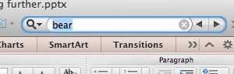

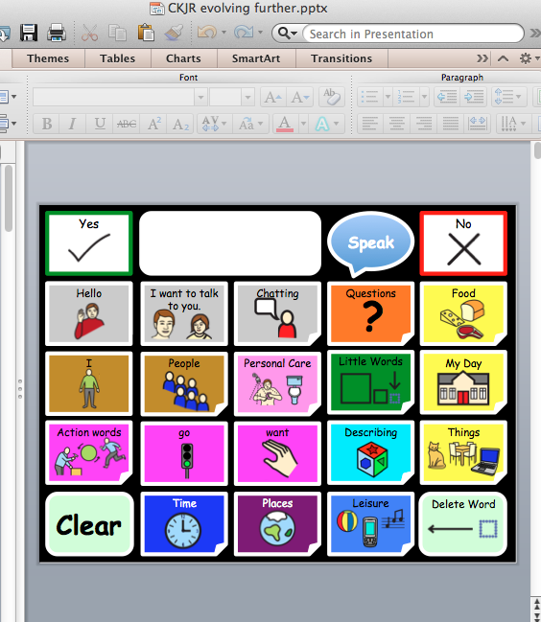

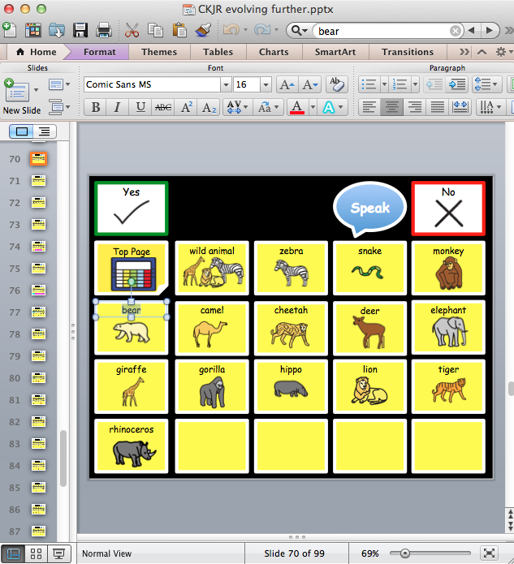

### Further Information

* ACE Centre are experts in AAC and Assistive Technology, they offer specialist services that include, assessment, training and recourses[12].
* Communication Matters, is a UK-wide organisation committed to supporting people of all ages who find communication difficult because they have little or no clear speech. They have a list and details of all AAC Assessment Services in the UK, and other AAC related information[13].
* PrAACtical AAC's Mission: To improve the level of AAC services available to individuals with significant communication challenges by supporting speech-language pathologists and other interested stakeholders[14].
* The International Society for Augmentative and Alternative Communication (ISAAC) works to improve the lives of children and adults who use AAC. ISAAC’s vision is that AAC will be recognized, valued and used throughout the world. ISAAC’s mission is to promote the best possible communication for people with complex communication needs[15].
* 1 Voice – Communicating Together, takes a family and social perspective on communication and recognises the great need for adult role models to inspire children and families alike. 1Voice promotes families supporting each other to overcome the isolation that being unable to speak can bring[16].
* Publications such as Other Ways of Speaking – The communication trust, you can download a copy of for free[17].
* Tracy Kovatch: A continuum of learning for People using Augmentative and Alternative Communication Systems.
* Gail Van Tatenhove’s Website[18].

# CommuniKate 20 Online!

This section gives an overview of how the standard version of CommuniKate 20 can be accessed online. Not only does this allow users, SLTs and members of the care network to examine the layout and style without any inconvenience, but it is useful in it’s own right for AAC users.

## What

If you visit [www.joereddington.com/CommuniKate 20](http://www.joereddington.com/communikate) you will find a fully responsive version of the CommuniKate 20 page set. Not only does this device allow speech output (tested on Windows Machines, Apple machines, iPads, iPhones, and a range of others. It also allows users to construct a ‘sentence’ and then, rather than speaking them aloud, search YouTube or Google Images with them. Moreover – we also have a ‘tweet’ button, so that users can tweet the utterance they have constructed.

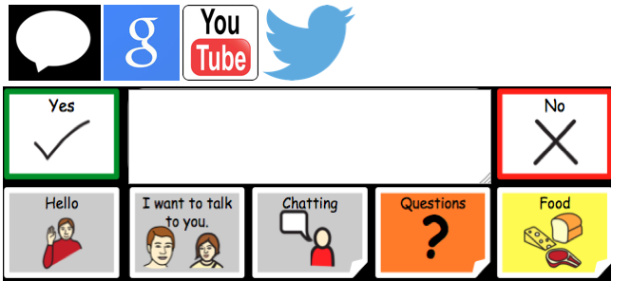

Figure 20: A screenshot of the online version of CommuniKate 20 showing the buttons for 'speak', 'search Google', 'search YouTube', and 'tweet'.

## Why

This section gives an overview of the motivation for providing an online version of CommuniKate. It presents several use-cases for both existing users of AAC and those who would benefit from electronic AAC but are unable to arrange it.

### ***For people with devices***

The online version of CommuniKate allows users, SLTs and members of the care network to examine the layout and style without any inconvenience, plus it lets users who have CommuniKate 20 search Google and YouTube. Moreover AAC devices unfortunately can often spent long periods of time away for repair (Shepherd et al., 2009; Ball et al., 2007)) and the online version of CommuniKate allows them to have a (limited) communication option during that time depending on their access method.

### ***For people without***

A £250,000 study by charity Communication Matters estimated that approximately 0.05% of the UK population require powered communication aids[19], however, it is the case that only 0.014% of the population has access to one. This leaves 21,000 without the ability to communicate, chiefly because of the cost (devices are available from a very small set of manufactures and cost an average of £2000).

We think 21,000 people who can't explain illness to a doctor, choose their dinner, or tell their family that they love them, is 21,000 too many. And that's just in the UK. So we worked hard to make AzuleJoe be there for anyone, regardless of money, or access. The limited version of CommuniKate 20 that can be accessed via AzuleJoe online isn’t going to be a long term solution for anyone, but it might temporarily help those who were using CommuniKate 20 on a device that has had to go back for repair, or for someone who wants to try AAC without making a significant financial commitment.

Moreover the AzuleJoe software is open access, meaning that you can download and modify it in any way to choose to make it work for you or someone who you care about. For more on the steps needed to make this work see the documentation at <http://joereddington.com/communikate/> .Does not work

## How

When you view <http://joereddington.com/communikate/> what you are actually looking at is the CommuniKate 20 pageset running on the AzuleJoe software. The software that became AzuleJoe dates back to 2009 when Joe built a system for his little brother. When we started to prepare CommuniKate 20 for public release in 2014 the software was significantly overhauled into something that developed it’s own identity.

## The name ‘AzuleJoe’…

Pronounced A-fo-lec-oy, AzuleJoe is a Basque word meaning Tiles.

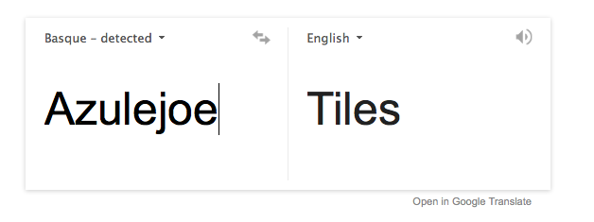

Apologies for the ‘out there’ nature of the word but when you are trying to find a word that sounds like it might be something to do with an AAC device and also includes “Joe” as the last three letters (CommuniKate 20 rather painted me into a corner) you are pretty happy with a short word that means Tiles. ☺

Joe

## 

## Guarantee

We are deeply and personally familiar with the effects on AAC users when a device becomes unsupported, or companies go out of business. In fact, one of the major reasons that both CommuniKate 20 and AzuleJoe are released under Open Licences is to avoid this ever happening. In this context, we will guarantee that the URL <http://www.joereddington.com/CommuniKate> will always contain the same version of CommuniKate 20 and AzuleJoe to stay consistent for users. More to the point, one of the reasons that the online version is hosted under Joe’s personal site is so that it can stay accessible for the entire foreseeable future. We also guarantee that there will never be a charge for this resource.

Even in the worst case of Joe disappearing entirely[20], all the code for AzuleJoe and CommuniKate 20 is stored on the very widely used website GitHub, and any programmer can very easily set up their own version in only a few minutes. One of the advantages of the open licences that we have used is that no permissions are required to do this: we have no right to stop someone even if we wanted to.

## Making your own local version

The AzuleJoe software is open access, meaning that you can download and modify it in any way to choose to make it work for you or someone who you care about. For more on the steps needed to make this work see the documentation at <http://www.joereddington.com/communiKate>.

# Rights and Licences

Through the development of CommuniKate 20 we have put a lot of time and effort into making sure that CommuniKate 20 could be used freely, easily, and legally wherever anyone wanted to use it. Our goal is to remove the barriers that AAC-users face, rather than add to them. This section discusses the licences used within the project, how they affect you, and why we choose them.

## Icons

We use the Mulberry symbol set, available from <http://straight-street.org/>. The Mulberry symbol set is a large (Version 2.4 includes over 2300 symbols) symbol set that is notable for being released under a **Creative Commons BY-SA** licence. The Creative Common licences are a set of licences used commonly in a wide range of situations (for example, editors to Wikipedia release their contribution under a Creative Commons licence). In this case the Mulberry symbol set has the following terms.

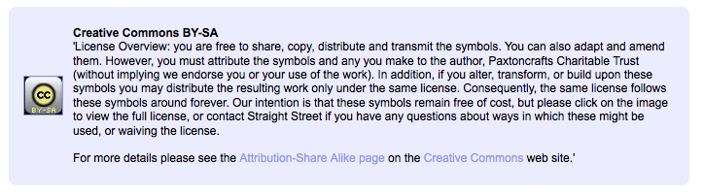

Figure 21: Licencing Screenshot from http://straight-street.org/

It is clear that the existence of the Mulberry Symbol set made CommuniKate 20 possible. If there had NOT been a symbol set with the Creative Commons licence then we would have had to pay for a licence for a more established symbol set, and, more importantly, users of the page set would also have been obliged to pay a licence fee to us the CommuniKate 20 page set.

During the creation of CommuniKate 20, we found ourselves modifying a wide range of symbols so that they more accurately depicted the semantics that we wanted to put across. We have gladly sent those new icons back to Mulberry to add to the symbol set (this sort of activity is, in it’s own right, an excellent argument for the use of free licences. As the licence terms specify, we release our modified icons under the same licence.

So you can use any icon you find in CommuniKate 20 for free, as long as it fits within the original Mulberry licence above.

## Page set

The icons, of course, are not the only intellectual property within an AAC package. Designing a pageset, partitioning concepts into pages, ensuring consistency, scaffolding the right amount of support without restricting and enabling the user to make the fullest use of this all require significant expertise, and experience, particularly when designing a system as widely used as CommuniKate 20. This is, of course, one of the reasons why major AAC companies aggressively promote their products as much on the value of the pageset as the capabilities of an individual AAC device design.

We believe that communication is a fundamental human right and so the CommuniKate 20 page set is also released under a creative commons licence. It can be used freely by any user who wants to try it, distributed by any SLT who wants to recommend it, and used in any college or school can make use of it. Entirely for free.

We do place some restrictions on the use of the pageset, which are carefully chosen to only affect situations where we believe there is a risk of the exploitation of AAC users.

To give some very quick examples of what is fair use:

* If a user, or their family downloads and uses CommuniKate 20 then we are absolutely happy, that’s entirely the point.
* If a for-profit AAC company releases it as a free download on their website without giving us any money, then we are again, absolutely fine with that. (Although it’s polite to mail us first).
* If a for-profit AAC company releases (a modified version) of CommuniKate 20, but with a different name, no licence release, or without credit to the creators, then we are **NOT** fine with that and that would be copyright theft. This is because the AAC community is a ‘slow information’ community and this runs a serious risk of users not being made aware of the range of free solutions available.
* If a for-profit AAC company sells a device that has CommuniKate 20 installed on it, then we are happy with that (providing it is right for the end user).
* If a for-profit AAC company charges an extra £30 to have CommuniKate 20 installed on a sold device, then we are NOT fine with that, and that would be copyright theft.

As a result, CommuniKate 20 is released under the Creative Commons Attribution-NonCommercial-ShareAlike 3.0 Unported License. To view a copy of this license, visit <http://creativecommons.org/licenses/by-nc-sa/3.0/>or send a letter to: Creative Commons, 444 Castro Street, Suite 900, Mountain View, California, 94041, USA.

## Online Voice

AzuleJoe is the software that demonstrates the CommuniKate 20 page set at www.joereddington.com/communikate.

AzuleJoe is also released under a wide license. Because it’s code rather than ‘design’ it isn’t released under Creative Commons Licenses (because they do not cover code), so it’s released under the GNU General Public License (<http://www.gnu.org/licenses/gpl.html>).

## 

## Screenshots

Taking screenshots of content on an AAC device turns out to be legally quite tricky. The problem is that the *graphical* *design of AAC software itself* is covered under legal protection, so if I design my own page on a commercial AAC device, using my own pictures that I’ve taken with my own camera, I still would be violating copyright if I were to share.

CommuniKate 20 is designed to work around this. All screenshots shown in this manual, and used on the online version of CommuniKate 20 were actually generated in PowerPoint first. Because the files are a product of PowerPoint rather than a software program themselves, we can freely use them.

Quick Aside…

This screenshot-centric approach was a very purposeful design decision. CommuniKate in general is designed to support extension and AzuleJoe in particular was designed to make it quick and easy. For people who have downloaded a copy of AzuleJoe and have it running locally – adding new pages is a simple as designing it in PowerPoint, and then adding the slide (as an image) to the AzuleJoe folder with a file containing the intended utterances.

## This Manual

Like CommuniKate 20 itself, this manual is released under the Creative Commons Attribution-NonCommercial-ShareAlike 3.0 Unported License. To view a copy of this license, visit <http://creativecommons.org/licenses/by-nc-sa/3.0/>or send a letter to: Creative Commons, 444 Castro Street, Suite 900, Mountain View, California, 94041, USA. This means that you can happily copy large chunks of it in handouts, essays, and other media as long as you mention the original source.

# Future Plans

This is the very first public release of both CommuniKate 20 and AzuleJoe. As such we have a wide variety of plans for the future, although we intend to be led by the user community. This section gives an overview of some of our better-developed future plans. Given that the development is open access, we would love to hear from people willing to help us with any of these directions, or people who would like to suggest their own.

## CommuniKate 20+

CommuniKate 20 is aimed a users with relatively moderate needs. Although it contains a large number of symbols, the behaviour of the device is very simple. Part of our on-going work is to bring to public view CommuniKate 20+, which would include systems to control morphology, grammar, and word endings and include a phonics keyboard.

## CommuniKate 12

As we discussed in the history section, CommuniKate 20 evolved out of a much simpler 12 button page set developed some years ago. That pageset is currently undergoing an overhaul, and rewrite to be publicly available in the near future for users with more severe needs.

## AzuleJoe

AzuleJoe as released here is a very simple design, carefully engineered to be as minimal and lightweight as possible. Future goals for the software include adding scanning features and working on a range of access methods. One significant goal is the ability to read/write to a variety of AAC device formats to make transfer of page sets simpler between manufactures.

## Localisation

The only reason that CommuniKate 20 is only available in English is because Kate and Joe embarrassingly only speak English. We’d love to provide more translations and CommuniKate 20 will be available in more languages just as soon as we find people who might be willing to help us with the translation.

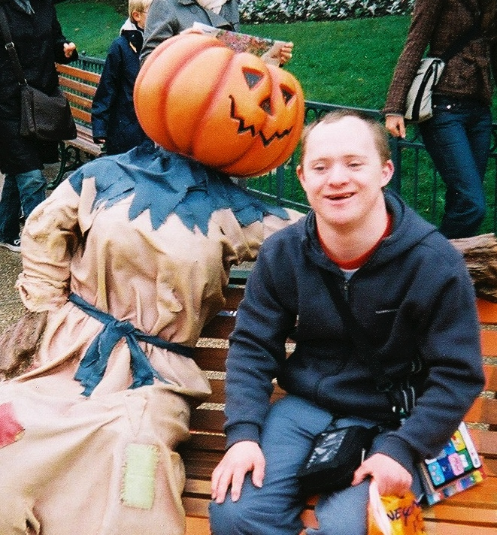

Figure 22: Kate’s brother at Disneyland Paris with CommuniKate translated into French.

# Appendices

## Testimonials

This section includes a selection of testimonials from a wide range of the AAC community. We are so very proud of the wonderful things that people have had to say.

*“My sister “Emily” has used a communication aid with CommuniKate for years now. Most importantly it means that she has a voice. Although she communicates using her voice in her own way, this cannot always be understood and to those who haven't learnt to speak, "Emily's language" it can be difficult and frustrating for everyone, especially her. Having CommuniKate means that she can be more independent, Emily can ask for something in a shop, tell someone what she would like to eat, say when something hurts or that she doesn't like something. Chatting to her on the phone is easier, she uses lots of actions and mining which cannot be seen, using CommuniKate means that Emily can still tell me what she wants to with a little less guess work of what actions she might be doing 100 miles away! Having a CommuniKate means that I can worry a little less because Emily has a way of communicating with others.”*

“Emily”'s big sister

*“Many of my adult clients with learning difficulties have more to say than a few pre-stored phrases – but don’t have the linguistic skills to use semantic compaction or a grammatically based language pack.*

*CommuniKate fills that gap, by providing messages from different themes and categories, giving users the ability to communicate for a range of functions that are meaningful to them, both personal and social.*

*I have seen several users who had previously been reluctant to use AAC grow in confidence to initiate their own ideas and observations as a result of using CommuniKate”.*

Alison Carpenter, Clinical Lead SLT

*“Our son began using CommuniKate 20, 11 years ago. Before that he used his own version of Makaton, mime, facial expressions, pointing and the odd unintelligible, whispered word. This was only useful to those who knew him well; others found him extremely difficult to understand.*

*He began with a low-tech CommuniKate 20 book that, he still occasionally uses today. It showed us that he could find his way around the pages and select what he wanted to say. This was not totally satisfactory as we had to be patient and wait for him to turn all the pages as well as look at what he was pointing at, as there was no voice.*

*When he got CommuniKate 20 on his communication aid he was able to have conversations with people other than friends and family for the first time. He asked for his own pint of beer in the pub, he could tell people how he was feeling and in a restaurant say what he wanted to eat. Everyone much more easily understands him.*

*Now he is able to express his own personality and some of the frustrations that had built up because others could not always understand him have disappeared.*

*Using CommuniKate 20 he can go to work placements and do tasks, which previously were unachievable, like taking and making the tea and coffee order and chatting to people.*

*New people are able to understand him quickly, which has been a great benefit to him when moving from the family home into supported living. His staff has not needed to learn all his personal and individual signs and ways of communicating because he has been able to use CommuniKate 20 on his communication aid.*

*Life for all concerned has became much happier and less frustrating. IT’S CHANGED ALL OUR LIVES FOR THE BETTER”.*

Parents of a CommuniKate 20 user

About the Authors

### ***Kate McCallum***

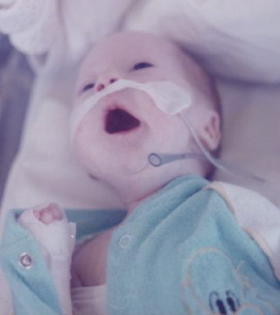I’ve lived and breathed AAC for the past 15 years professionally, working in a range of settings, an assessment centre, an SEN school, for a major AAC supplier, and currently as a trustee for the charity, 1 Voice – Communicating Together and in my day job as an AAC Technician at Beaumont College. I also qualified as an Occupational Therapist in 2013.

My journey into AAC began when I was much younger. I was 5 when my brother was born with complex special needs. As I was growing up each time I threw a penny in a wishing well or blew the candles out on my birthday cake I would wish the same wish, it was that one day my brother would speak.

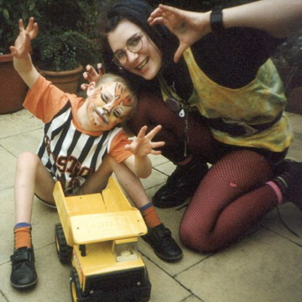My brother’s speech is unintelligible to those who do not know him, due to a physical and intellectual disability. He has difficulties with both expressive and receptive language but he has always had a desire to communicate and will go to great lengths to try to make him self understood. All of his life I have witnessed his frustration trying to get his message across. When his attempts to communicate have been ignored or misunderstood he has, had periods when he has isolated himself and retreated from normal everyday activity or displayed what is perceived as challenging behaviour, as a result of watching this day in day out I am a strong believer that all behaviour is communication.

Despite being in special education and services all his life he was only ever given limited access to AAC, in the form sign language. Age 2 his SLT recommended he learn Makaton and this gave him an avenue to communication and supports his understanding of the spoken word. Today Makaton remains a valid and valuable communication strategy for him however his idiosyncratic communication behaviours, mean unless you know him really well you can’t understand what he is saying and he has to rely on someone interpreting his communication attempts. This was a huge barrier to him communicating outside of his immediate circle of family and friends who knew him really well.

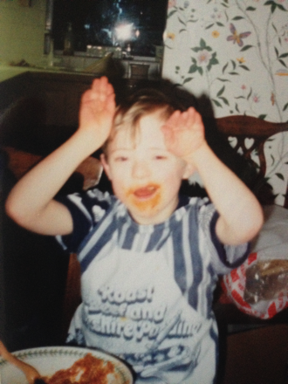I made him a communication board on the back of an old cereal packet with pictures cut out of an old Argos catalogue. He used it well and when he was 15 I use the same sort of idea to make him is his first communication book. Neither of these low - tech strategies were effective if the person with him could not see him for example when in the back of the car.

In 1995 I left school and went volunteering at an outdoor centre that catered for people with disabilities. I met a lady who was using an ORAC some years later the same lady was using a DeltaTalker with LLL. I knew that this was to cognitively demanding for him because of his learning difficulties. However the concept of pressing a button a getting a words out was so exciting I spent the next few years trying to find out what these talking boxes were and working out a how something like this could work for him.

In 2001 my brother got his first communication aid but it did not have a language pack that was appropriate for him so I wrote one. This was the beginning of CommuniKate. He progressed so quickly that soon 12 buttons did not give him the access to the volume of vocabulary he needed . Hence, CommuniKate 20 was written.

### ***Joe Reddington***



Figure 23: Richard getting Joe's attention. Possibly vice-versa

I’ve been working on AAC-related things for some years now, sometimes paid to do it, sometimes not. In many ways my little brother is very lucky in terms of AAC, he’s surrounded by technically competent people and has a well developed and dedicated care network. There is no question that AAC completely changed his life (via Kate, who was the tech who made it work for him and Alison his SLT) and I’d like to make sure that more people get the same opportunity. That’s one of the reasons I built things like [the Domesday Dataset](http://joereddington.com/aac-and-the-domesday-dataset/), which revealed a horrific postcode lottery in AAC provision and its one of the major reasons I’ve been working with Kate to bring CommuniKate 20 into the public view. In 2014 I left behind a university career to start a charity that, amongst other things, hopes to make, AAC devices available to all that need them.

## Bibliography

1. Joseph Reddington. The domesday dataset: linked open data in disability studies. Journal of Intellectual Disabilities, 2013.
2. Ball, Laura J., et al. "Duration of AAC technology use by persons with ALS." Journal of Medical Speech Language Pathology 15.4 (2007): 371.
3. Shepherd, Tracy A., et al. "Reliability of speech generating devices: A 5-year review." Augmentative and alternative communication 25.3 (2009): 145-153.
4. Halloran, John, and M. Emerson. "LAMP: language acquisition through motor planning." Prentke Romich Company (2007).
5. Gregory W Lesher, Bryan J Moulton, Gerard Rinkus, and D Jeffery Higginbotham. 2000a. A universal logging format for augmentative communication. Citeseer.
6. Gregory W Lesher, Gerard J Rinkus, Bryan J Moulton, and D Jeffery Higginbotham. 2000b. Logging and analysis of augmentative communication. In Proceedings of the RESNA Annual Conference.
7. Frank Deruyter, David McNaughton, Kevin Caves, Diane Nelson Bryen, and Michael B Williams. 2007. Enhancing AAC connections with the world. *Augmentative and Alternative Communication*, 23(3):258–270.
8. Schlosser, R. W.; Wendt, O. (2008). "Effects of augmentative and alternative communication intervention on speech production in children with autism: a systematic review". *American Journal of Speech-Language Pathology* **17** (3): 212–230. [doi](http://en.wikipedia.org/wiki/Digital_object_identifier):[10.1044/1058-0360(2008/021)](http://dx.doi.org/10.1044%2F1058-0360%282008%2F021%29). [PMID](http://en.wikipedia.org/wiki/PubMed_Identifier) [18663107](http://www.ncbi.nlm.nih.gov/pubmed/18663107).
9. Millar, D.C.; Light, J.C.; Schlosser, R.W. (2006). "The impact of augmentative and alternative communication intervention on the speech production of individuals with developmental disabilities: A research review". *Journal of Speech, Language, and Hearing Research* **49** (2): 248–264. [doi](http://en.wikipedia.org/wiki/Digital_object_identifier):[10.1044/1092-4388(2006/021)](http://dx.doi.org/10.1044%2F1092-4388%282006%2F021%29).
10. Preston, D.; Carter, M. (2009). "A review of the efficacy of the Picture Exchange Communication System intervention". *J Autism Dev Disord* **39** (10): 1471–1486. [doi](http://en.wikipedia.org/wiki/Digital_object_identifier):[10.1007/s10803-009-0763-y](http://dx.doi.org/10.1007%2Fs10803-009-0763-y). [PMID](http://en.wikipedia.org/wiki/PubMed_Identifier) [19495952](http://www.ncbi.nlm.nih.gov/pubmed/19495952).
11. Schlosser, R. W.; Lloyd, L. L. (2003). "Chapter, 16: Effects of AAC on Natural Speech Development". In Schlosser, R. W. *The Efficacy of Augmentative and Alternative Communication: Toward Evidence-Based Practice*. USA: Academic Press. [ISBN](http://en.wikipedia.org/wiki/International_Standard_Book_Number) [978-0-12-625667-3](http://en.wikipedia.org/wiki/Special:BookSources/978-0-12-625667-3).

1. <http://joereddington.com/communikate/support/>
2. <http://uk.dynavoxtech.com/training/online/recorded-web-classes/details/default.aspx?id=228>
3. <http://sensorysoftware.com/grid-software-for-aac/grid2_aac_software/>
4. <http://joereddington.com/communikate/>
5. Kate and Joe. Obviously.
6. <http://joereddington.com/communikate/support/>
7. <http://www.pagesetcentral.com/>
8. <https://grids.sensorysoftware.com/en>
9. And AzuleJoe, but more on that later….
10. Technical people will even now be mentioning that Chrome is only **mostly** open source, which is fair, but the original point stands.
11. Joe’s brother’s device was once left on the roof of the car, fell off, and then was run over. It continued to work. We would like to applaud the construction of the AdVOCAte.
12. <http://acecentre.org.uk/>
13. <http://www.communicationmatters.org.uk/>
14. <http://praacticalaac.org/>
15. <https://www.isaac-online.org/english/home/>
16. <http://www.1voice.info/>
17. <https://www.thecommunicationtrust.org.uk/resources/resources/resources-for-parents/other-ways-of-speaking.aspx>
18. <http://www.vantatenhove.com/>
19. <http://www.communicationmatters.org.uk/shining-a-light-on-aac>
20. We like to think this is the *worst* case…